VLSI Internship — Task 1
Introduction to VLSI Design Flow and Basic Digital Logic Implementation

1. Objective
Task-1 builds a strong foundation in VLSI fundamentals by covering the following areas:
- What VLSI is and where it is used
- How a VLSI chip is designed from idea to fabrication
- Basic digital logic concepts that form the core of VLSI systems
This task focuses on conceptual clarity, which is essential before writing HDL (Verilog) code in later stages.

2. What is VLSI?
VLSI stands for Very Large Scale Integration — the process of integrating millions or billions of transistors onto a single silicon chip.
Examples of VLSI chips:
- Microprocessors (Intel, AMD)
- Mobile SoCs (Qualcomm Snapdragon, Apple M-series)
- Memory chips (RAM, ROM)
- GPUs and AI accelerators
Applications of VLSI:
- Smartphones
- Computers and laptops
- Automotive electronics
- Medical devices
- AI and machine learning hardware
- IoT and embedded systems

3. VLSI Design Flow
The standard VLSI design flow used in the industry consists of nine stages, taking a chip from concept through to a tested, working product. Task-1 focuses on the first two stages (System Specification and Architecture Design) and gives an overview of the rest to prepare for RTL work in later tasks.
1. System Specification
- Define what the chip should do
- Set performance, power, and area constraints
2. Architecture Design
- High-level block diagram
- Functional blocks and data flow
3. RTL Design
- Coding the design using Verilog / VHDL
- Register Transfer Level description
4. Functional Verification
- Simulating RTL to check correctness
5. Synthesis
- Converting RTL to a gate-level netlist
6. Physical Design
- Floorplanning, placement, and routing
7. Timing & Power Analysis
- Ensuring speed and power targets are met
8. Fabrication
- Manufacturing the chip
9. Testing & Validation
- Checking the fabricated chips

Digital Logic Fundamentals
Understanding truth tables is mandatory in VLSI, since every digital circuit's behavior is ultimately defined by one. The six basic logic gates and their truth tables are shown below.

AND Gate : .
A | B | Output
0 | 0 | 0
0 | 1 | 0
1 | 0 | 0
1 | 1 | 1

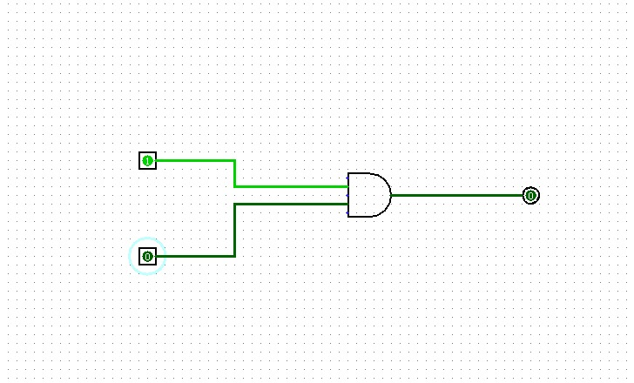

OR Gate :
A | B | Output
0 | 0 | 0
0 | 1 | 1
1 | 0 | 1
1 | 1 | 1

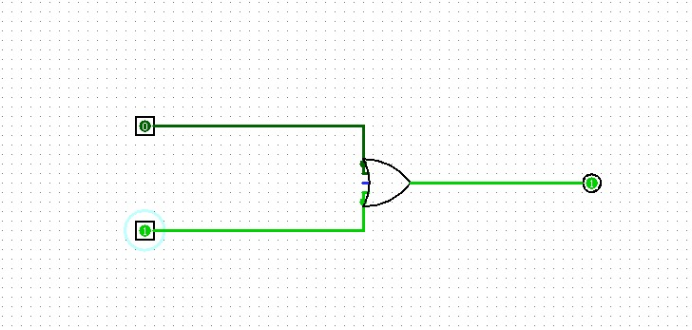

NOT Gate:
A | Output
0 | 1
1 | 0

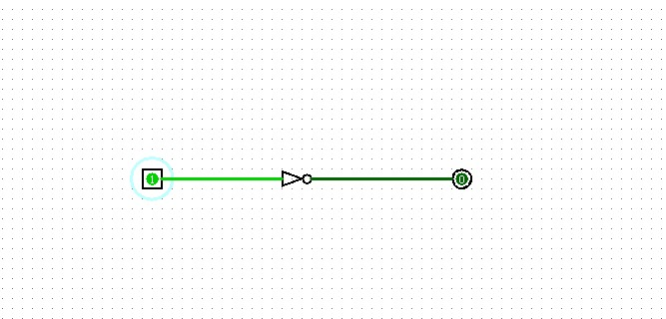

NAND Gate
A | B | Output
0 | 0 | 1
0 | 1 | 1
1 | 0 | 1
1 | 1 | 0

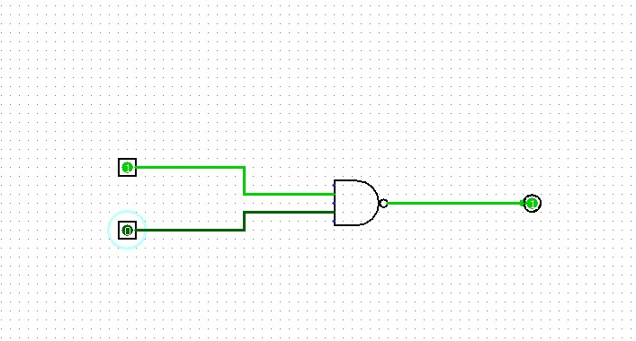
NOR Gate
A | B | Output
0 | 0 | 1
0 | 1 | 0
1 | 0 | 0
1 | 1 | 0

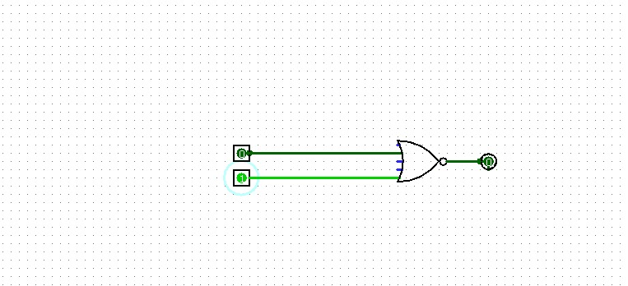

XOR Gate:
A | B | Output
0 | 0 | 0
0 | 1 | 1
1 | 0 | 1
1 | 1 | 0

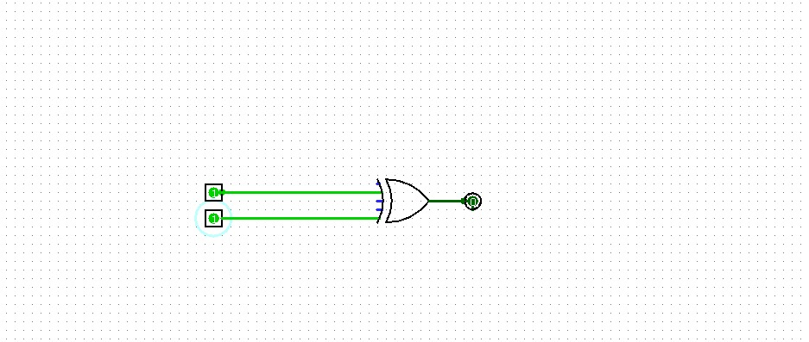

XNOR Gate
A | B | Output
0 | 0 | 1
0 | 1 | 0
1 | 0 | 0
1 | 1 | 1

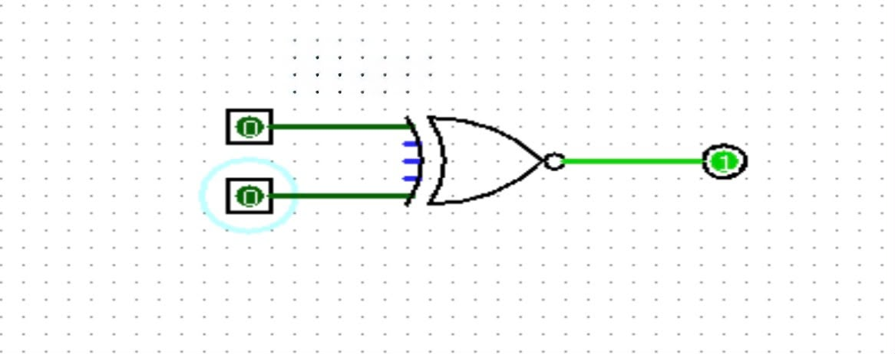

Half Adder
A Half Adder is a basic combinational circuit built from an XOR gate and an AND gate. It adds two single binary digits and produces a Sum and a Carry output.
Half Adder Logic:
- Sum = A XOR B
- Carry = A AND B
Half Adder Truth Table
A | B | Sum | Carry
0 | 0 | 0 | 0
0 | 1 | 1 | 0
1 | 0 | 1 | 0
1 | 1 | 0 | 1

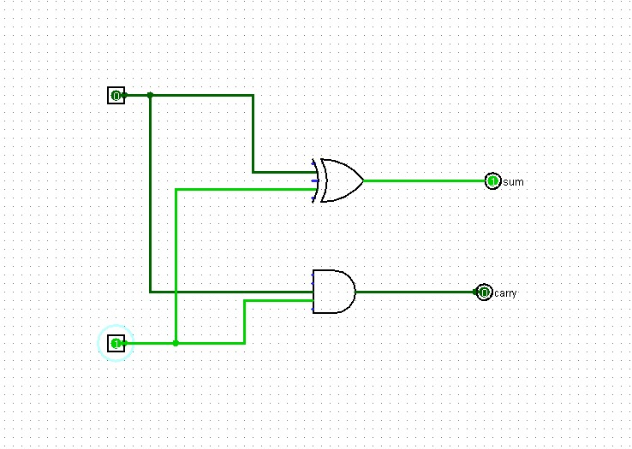

Full Adder
- Sum = A XOR B XOR Cin
- Cout = (A AND B) OR (Cin AND (A XOR B))

Full Adder Truth Table
A | B | Cin | Sum | Cout
0 | 0 | 0 | 0 | 0
0 | 0 | 1 | 1 | 0
0 | 1 | 0 | 1 | 0
0 | 1 | 1 | 0 | 1
1 | 0 | 0 | 1 | 0
1 | 0 | 1 | 0 | 1
1 | 1 | 0 | 0 | 1
1 | 1 | 1 | 1 | 1

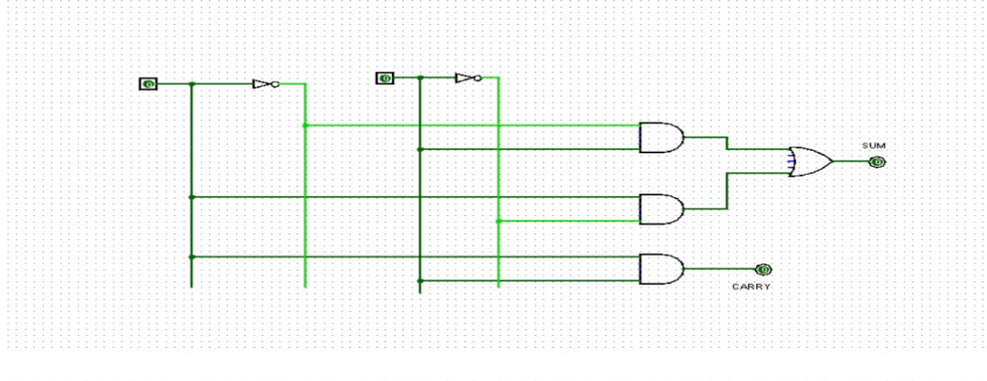

Observations
IN HALF ADDER:
Inputs used: A, B
Output behavior: SUM, CARRY

Key Learning Outcomes
- Explained what VLSI is and where it is used
- Described the complete VLSI design flow
- Understood digital logic fundamentals
- Built and simulated basic logic circuits
- Prepared for RTL and Verilog-based tasks

